BI reports

* Creation of data model for Receivables.
* Use dependency parameters & List of Values (LOV).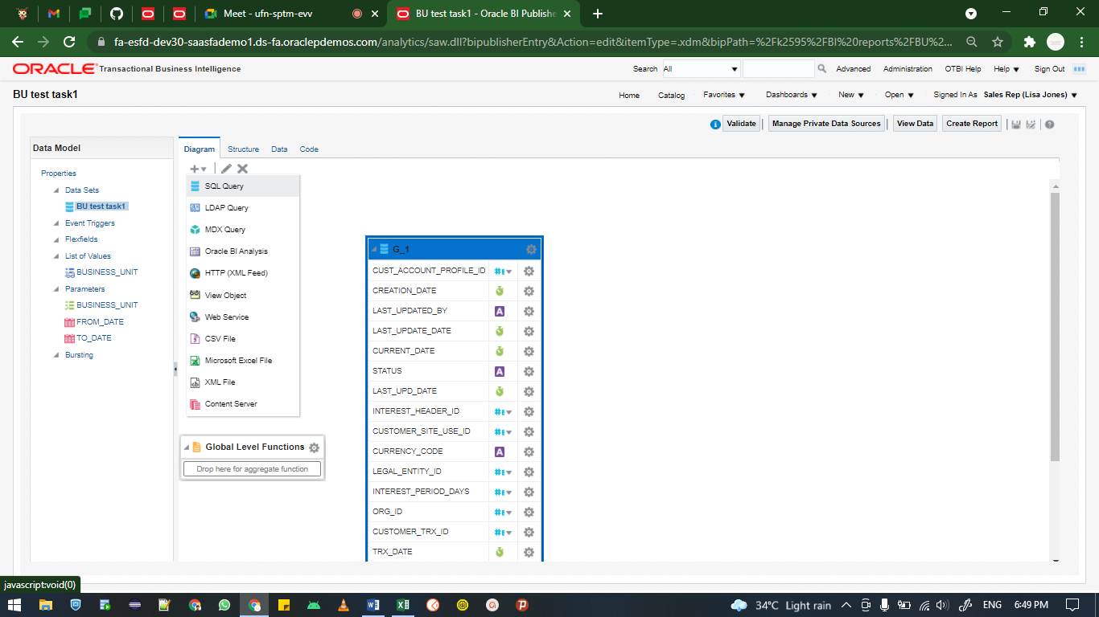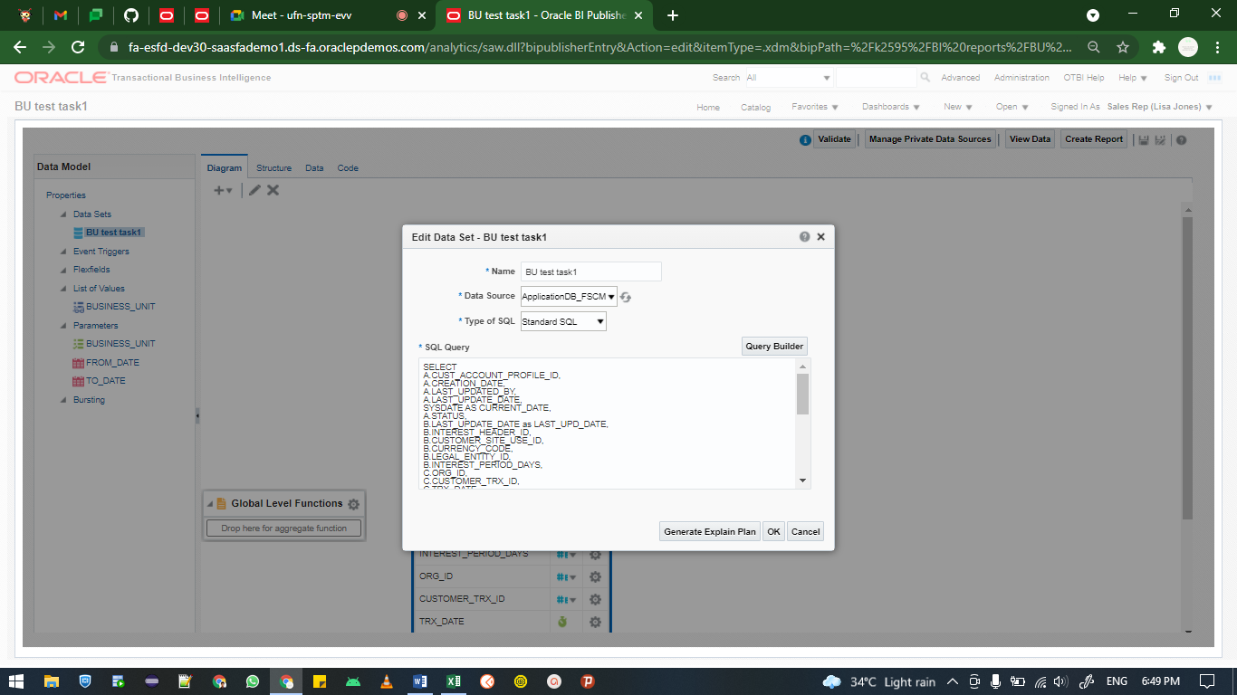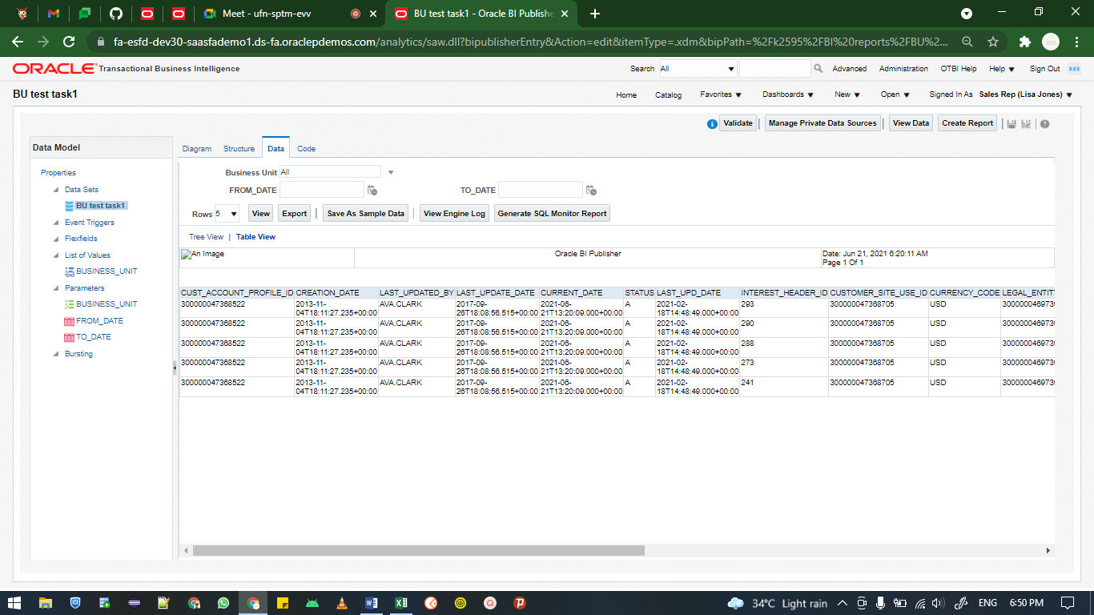

Ms word template creation:

* Upload the data model in ms word
* Goto table wizard
* Select the datamodel and click ok
* Select the table as report format
* Select the required columns from the wizard and click OK
* Select the group by drop down and select BU as group-by column
* Click ok and select the BU and double – tap on it
* On the pop-up window
* Select the advanced tab and type inside the code block as “<?if:BUSINESS_UNIT=’Finance UK’?>”
* And goto legacy tools in the developer tab in ms word then click on the AB icon (Text Form Field icon)
* Then code it as “<?end if?>”
* Save file as rtf format and upload the template into layout for report for selected data model

